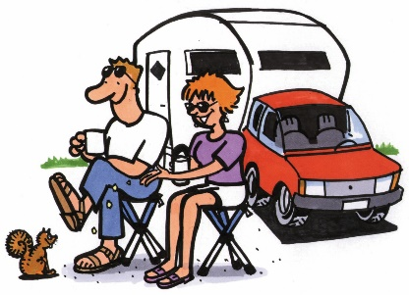
Unit 4/ Intro + Reading 1: Vocabulary tasks

1 These people are at a _____________________ .
They sleep in a ____________________ .
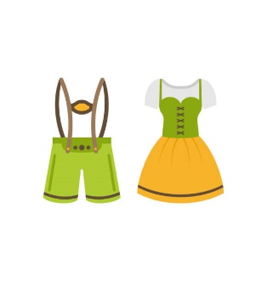
At the moment they are sitting outside, drinking tea and feeding a squirrel.

2 These are the ____________________ clothes in Bavaria.
3 There are some _________________ eggs in the pan.

4 Robert de Bruce was the ________________ (“boss”) of the Scots in their
fight against the English.

5 Fast food is nice and tastes good, but it’s not very ____________________
(“good for your body”).

6 Some people in Scotland ______________________ (“erfanden”) a new dish:
fried chocolate bars.

7 Haggis is a ____________________ (“Art”) of meat sausage.

8 The Highland Games are a famous Scottish ______________________
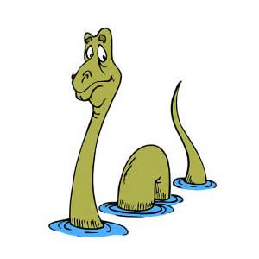
(“championship”)

9 This is __________________ (“seltsam”). I think I’ve just seen the Loch
Ness monster!!

