Adjectives (Comparative forms)

Which of these animals is faster?
A rabbit is ____________ _______ a turtle.
Which of these animals is bigger?
An elephant is __________ _______ a horse.
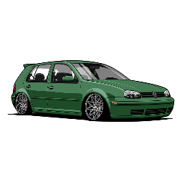
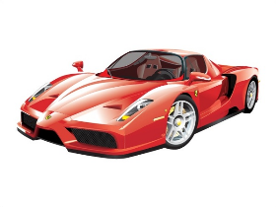
Which of these cars is more expensive?
A Ferrari is ________________ _______ a VW.

Short adjectives (one syllable, two syllables +y)
fast - _______________
big - ______________
easy - _________________
cool - ____________________
than
happy - ____________________
fit - __________________
good - _________________
bad - __________________
Long adjectives (two syllables and more):
expensive - ____________________________
dangerous - _____________________________
______________________________________________________
Olivia is 12 years old and Luke is 12, too.
as … as …
not as … as …
Olivia is _____ ________ ______ Luke.
Dave is 13.
So Dave is not _____ _______ _____ Luke.

