Vocabulary Test Unit 3/ Text Topic 2

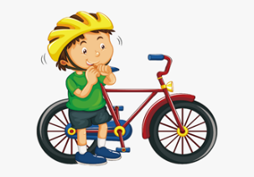
1 A person who does sports and is good at sports is a _________________________ or ______________________ .
2 Most people who do dangerous sports wear a___________________ .
3 Olivia is 12 and Luke is 12, too. So Olivia is _______ old _______ Luke.
4 It‘s a long way from London to Wales. -__________________ (endlich) they arrive at the outdoor centre.
5 At the centre you can decide _____________________ (zwischen) surfing and canoeing.
6 Dave isn‘t good at sports. So he‘s a bit ____________________ (besorgt).
Find the opposites:
7 easy – _______________________
8 loud/ noisy – _______________________
9 safe (sicher) – __________________________
10 weak (schwach) - ________________________________

